Art and Drama
2019
B.Ed 2nd Sem
FEEDBACK SUMMARY Date: 18/05/2019
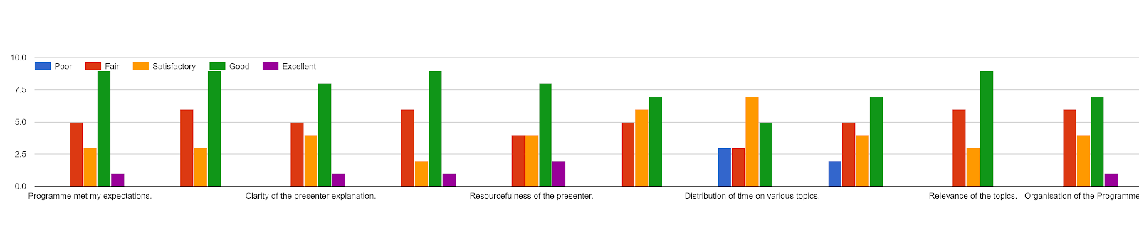

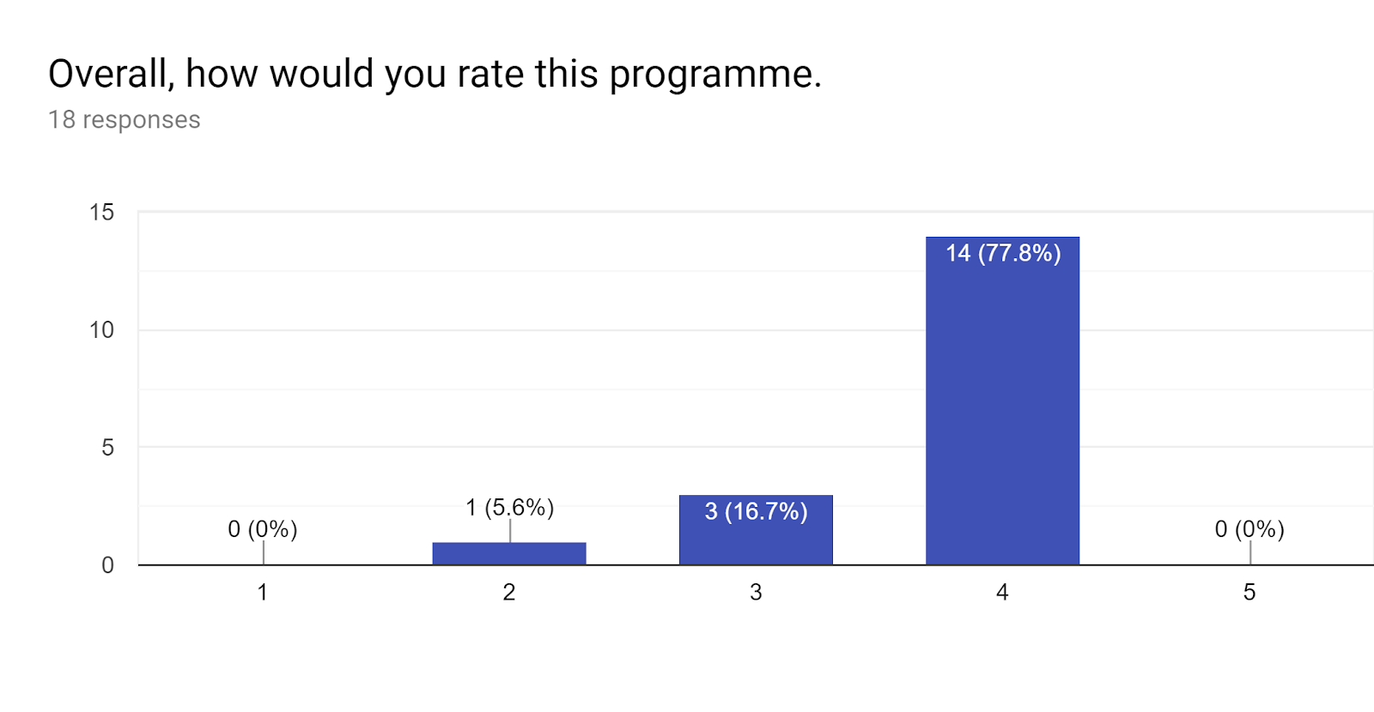
If you answered “Poor” or “Fair” to any of the above please indicate your reasons:1 response
Time was too limited and we have to rush every activity with less time to discuss and prepare with the group members.

Do you have any suggestions for future programmes? Please state:7 responses
- Time management
- I wish that it start on time
- I wish we will have a proper auditorium for such activities
- EPC course should be conducted at the beginning of the month or not very close to viva voce so that sufficient time is given for the report writing . The student teacher comprises of different people with own share of problems especially health issues so those people find much difficulties in finishing off the work all at once within a short period of time which worsen the ill health
- The mentor was very professional and exceeds more than our expectations. I think it will be good if we give more time to be more organized and demand full participation from all the students in the activities.
- The program for activities should not be rushed at one go.
- Such programmes should be conducted for atleast a week

Additional Comments (if Any):2 responses
- Had a great time
- Time management and duration of classes be organized Pre hand so that students are prepared mentally and the facilitators will have enough time .

